# LISTENING IS AN ART

Listening is a skill most used by all of us, but we get little training in this. On the other hand, we are formally trained in skills like speaking. reading, and writing. It is primarily so because listening is usually taken for granted. In the name of listening what people do most of the time is hearing. Let us see how these two terms can be distinguished.

# LISTENING VS HEARING

Hearing takes place when something disturbs the atmosphere. For example, a truck rolling by on the road in front of our house would be just heard and not listened to.

Listening is different. It expands on hearing when we pay attention to the meaning of what we hear. Therefore, listening is all about consciously, actively, and systematically processing information.

# TYPES OF LISTENING

In order to hone our listening ability, it is advisable to know the different types of listening that we need to employ on different occasions.

* **Content listening:** The primary focus is on understanding the message sent by the speaker, and to gather and understand the information. Therefore, it is also known as informative listening.
* **Empathetic listening:** This is also known as therapeutic/relationship listening. Counsellors, doctors, and psychiatrists also use this type of listening in their profession. Since you try to understand the speaker's situation as an empathetic listener, it helps in strengthening the relationship between you and the speaker.
* **Appreciative listening**: While listening to music or watching movie you use appreciative listening since you appreciate the lyrics, direction, melody, style, or dialogue delivery. Thus, it is listening tor pleasure or enjoyment.
* **Analytical listening**: The purpose of this listening is two-fold. On one hand, you try to absorb the message and on the other, you attempt to analyse the ideas or facts and make critical judgement.

# PROCESS OF LISTENING

Becoming a good listener requires us to understand how listening happens. Essentially a cognitive process, listening involves the following stages.

* **Sensing :** At this stage, the listener has physical hearing of the message because the sound waves fall on the eardrum, as a result of which he/she perceives the sounds.
* **Recognizing :** After hearing the physical sounds, the listener identifies and recognizes the pattern of sounds.
* **Interpreting:** Now the listener starts decoding the message. As he/she listens, he/she employs his/her own values, beliefs, needs, ideas, etc. to interpret the speaker's message.
* **Evaluating:** After he/she understands what the message actually means, he/she critically evaluates it. He/she assesses its strengths and weaknesses, its accuracy, reliability, and feasibility.
* **Responding:** At this stage, the listener is ready to respond and react. He/she shows his/her rejection or acceptance, or understanding or confusion.
* **Remembering or memorizing** This is the final stage of listening. Good listening enables the listener to retain the information for future reference.

POOR LISTENING VS EFFECTIVE LISTENING

The major differences between a poor listener and an effective listener are as--

Poor Listener

1. Gets distracted easily.

1. Finds it difficult to listen to complex material; has the tendency to read light and recreational materials.
2. Tends to enter into unnecessary arguments.
3. Resists new ideas.
4. Pays too much attention to appearance and delivery.
5. Waits for his/her turn to speak.

Effective Listener

1. Thinks and mentally summarizes, weighs the evidence, listens between the lines to the tone of voice and evidence.
2. Fights against distractions and knows how to concentrate.
3. Takes notes and organizes important information.
4. Listens for ideas.
5. Pays attention to the body language, tone, and style, along with the message being conveyed by the speaker.
6. Patiently listens to the speaker and responds as and when required.

# REASONS FOR POOR LISTENING

There are several reasons for poor listening. We will examine these reasons in this section.

1. Listening training is unavailable:

Most people are formally trained in the major communicative skills of writing, reading, and speaking. While workshops and conferences provide opportunities to improve writing and speaking skills, it is difficult to find training to sharpen listening skills.

1. Speed of thought is more than speed of speech:

Another reason for poor listening skills is that people can think faster than they can speak. When we listen to the average speaker, we are using only 25 per cent of our mental capacity. We still have 75 per cent of unutilized mental capacity. So, our mind starts wandering..

1. We are inefficient listeners:

Numerous tests confirm that humans are inefficient listeners. We often comprehend and retain only one fourth of what we hear. We all want to be more than 25 per cent efficient. Poor listening is the cause of many personal and professional problems.

# ADVANTAGES OF GOOD LISTENING

Following are the advantages of good listening:

1. We generally find that good listeners are better performers. Thus, listening starkly differentiates between a poor and a good performer.

2. Good listening ability increases knowledge, develops critical thinking, and broadens opportunities.

3. Listening skills help us build effective relationships in our personal as well as professional life.

4. It prevents miscommunication.

5. It also facilitates solving problems in our personal life and at workplace.

6. Effective listening helps in sharing emotions, ideas, and experiences.

7. Good listening also improves decision-making and critical thinking.

# TECHNIQUE FOR EFFECTIVE LISTENING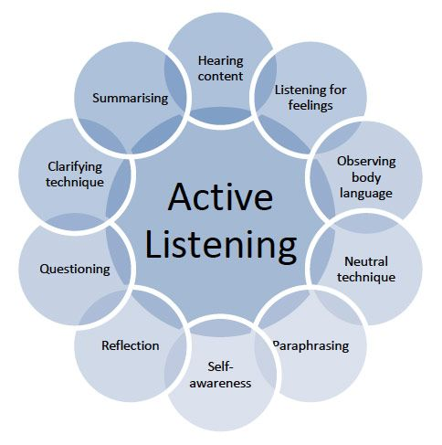

# SUMMARY

Listening is an often ignored but yet a very important communication skill. Active listening requires the listener to understand, interpret, and evaluate what is being said. The ability to do this can improve personal and professional relationships remarkably by eliminating misunderstandings, strengthening cooperation, and improving under-standing. Empathy plays a very important role in listening. Listening skills can be improved by removing the common myths about listening from our minds. The traits of a good listener are being non- evaluative, paraphrasing, reflecting implications, reflecting hidden feelings, inviting further contributions, and responding non-verbally.